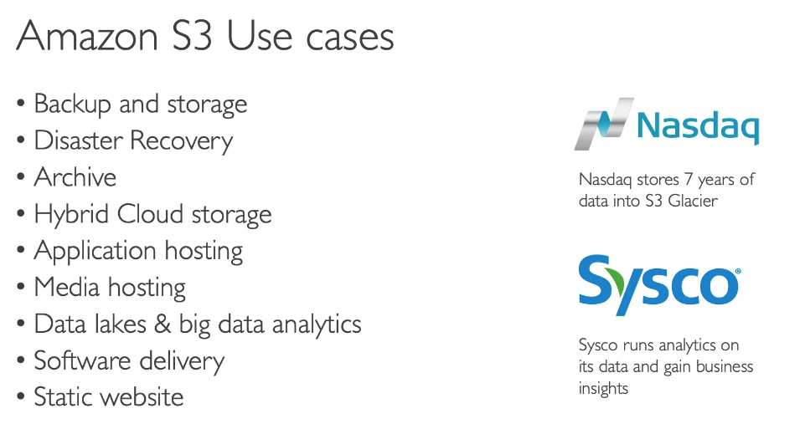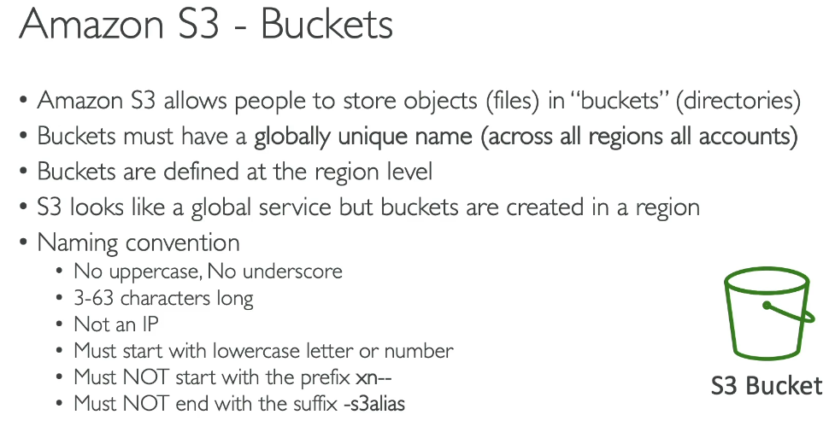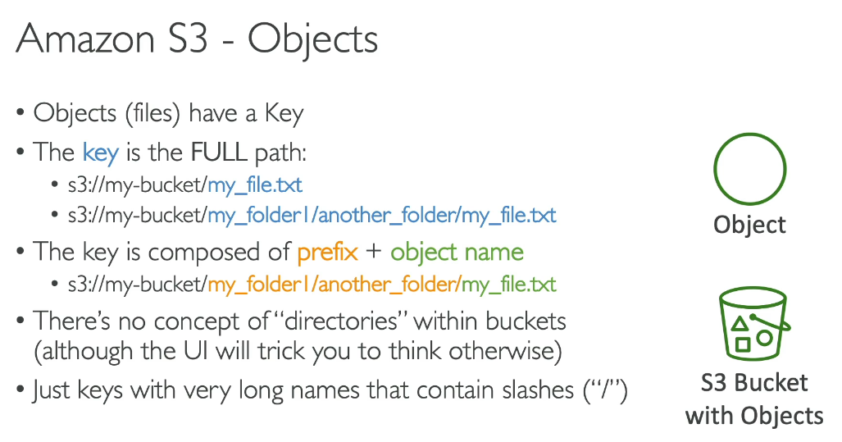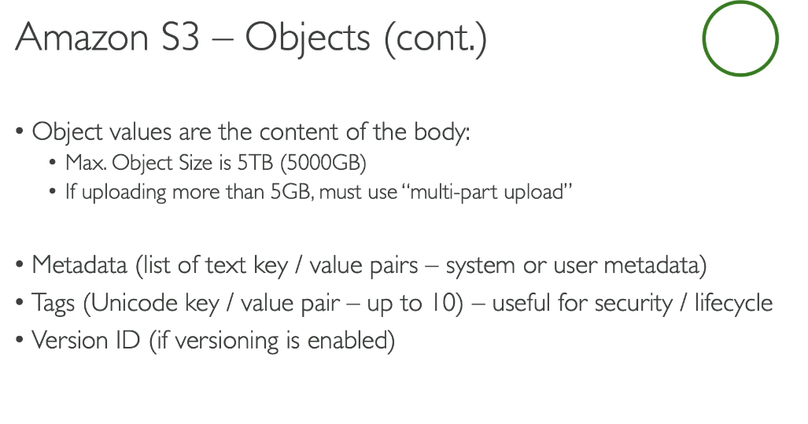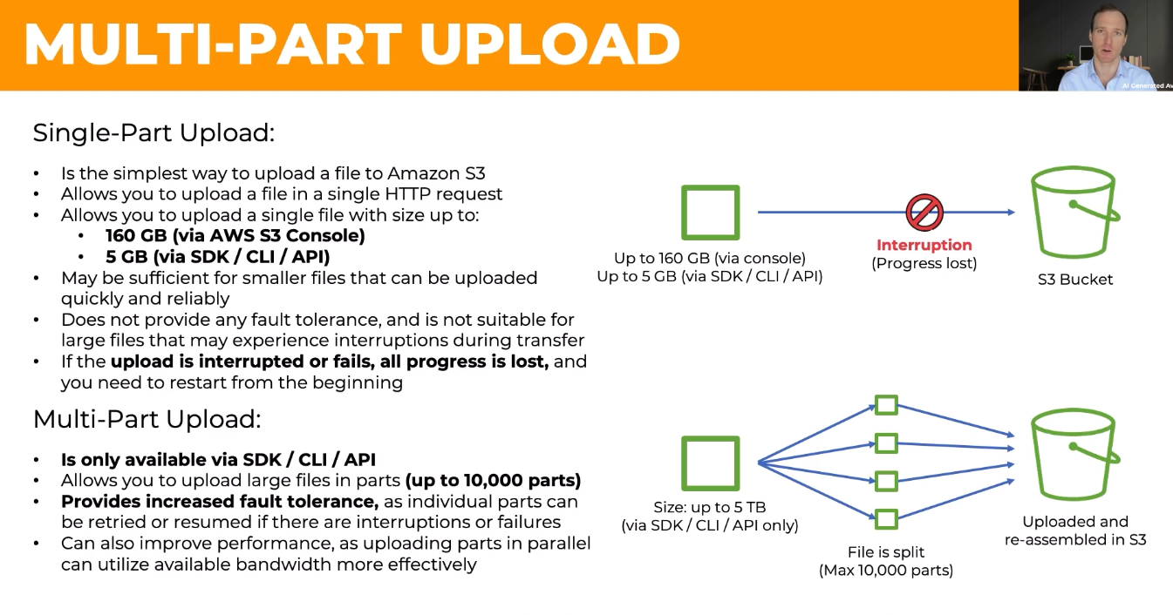  
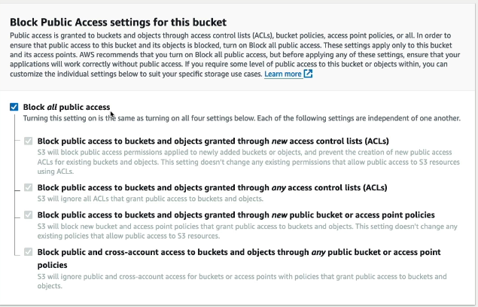  
Encryption:  
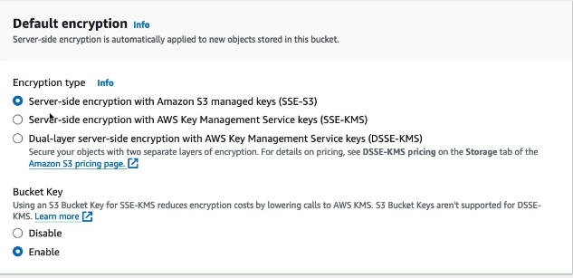

Note: Add the files and folders you want to upload to S3. To upload a file larger than 160GB, use the AWS CLI, AWS SDK or Amazon S3 REST API.

**DSSE-KMS (Dual-Layer Server-Side Encryption with AWS KMS Keys) Explained:**

DSSE-KMS applies two independent layers of AES-256 encryption to objects when uploaded to S3, providing enhanced security compared to standard SSE-KMS.

How It Works:

Layer 1: Data is encrypted using a unique data encryption key (DEK) generated by AWS KMS

Layer 2: The already-encrypted data is encrypted again using a separate AES-256 encryption key managed by Amazon S3

Key Features:

* Each layer uses a different implementation of AES-256-GCM algorithm
* Separate cryptographic implementation libraries for each layer
* Individual data encryption keys per layer
* AWS KMS manages your encryption keys with full audit trail

Why Use DSSE-KMS:

* Compliance: Meets rigorous security standards requiring multilayer encryption (e.g., US Department of Defense)
* Enhanced Security: Protects against low probability of vulnerability in a single encryption layer
* Control: Full control over customer managed keys with permissions and rotation schedules
* Simplicity: No need to invest in client-side encryption infrastructure

Benefits:

* Query and analyze dual-encrypted data with AWS services (Athena, SageMaker)
* Audit trail showing who accessed which objects and when
* Additional layer of access control through KMS key permissions
* Vetted and accepted for top-secret workloads

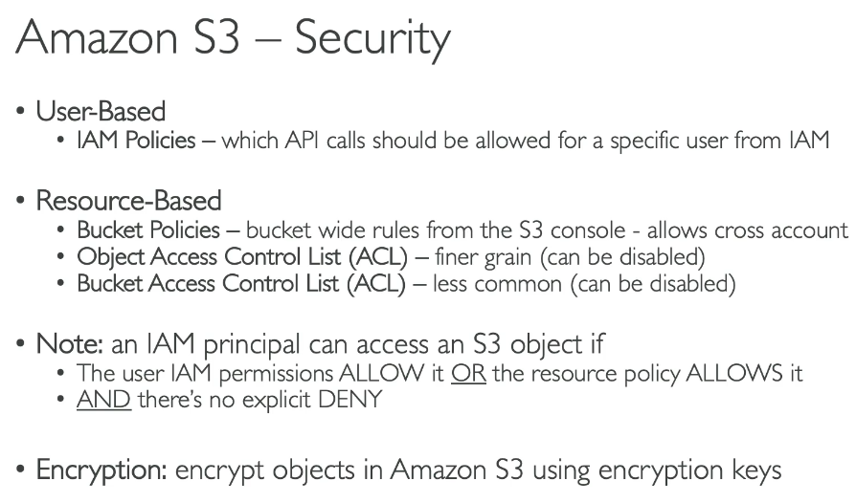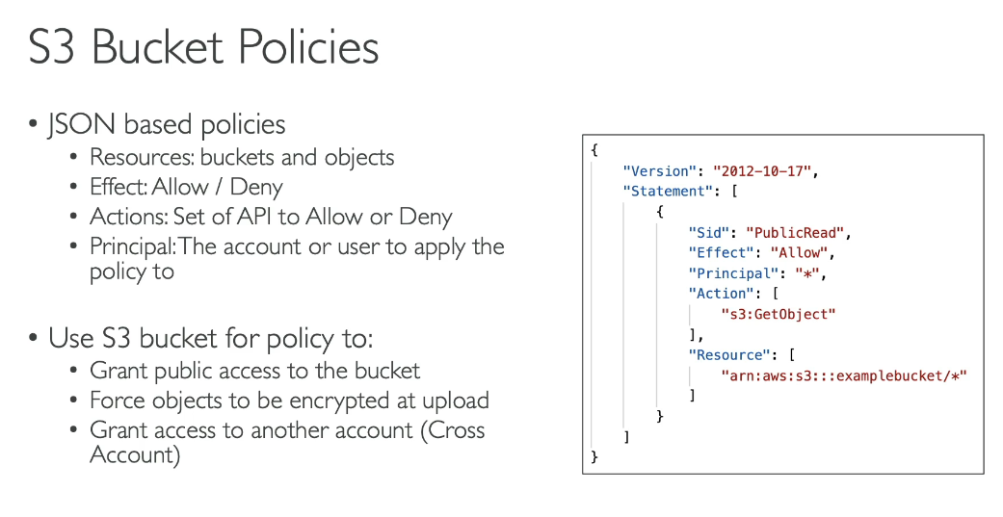The "Principal" element in a JSON policy specifies WHO is allowed or denied access to a resource.

Key Points:

* In Resource-Based Policies (S3 bucket policies): The Principal element explicitly identifies which users, accounts, services, or entities can access the resource
* In Identity-Based Policies (IAM policies): The Principal is implicit - it's automatically the user or role the policy is attached to, so you don't need to specify it

Principal can specify:

* AWS account IDs
* IAM users
* IAM roles
* AWS services (like S3, Lambda)
* Federated users
* Anonymous users (using "*")

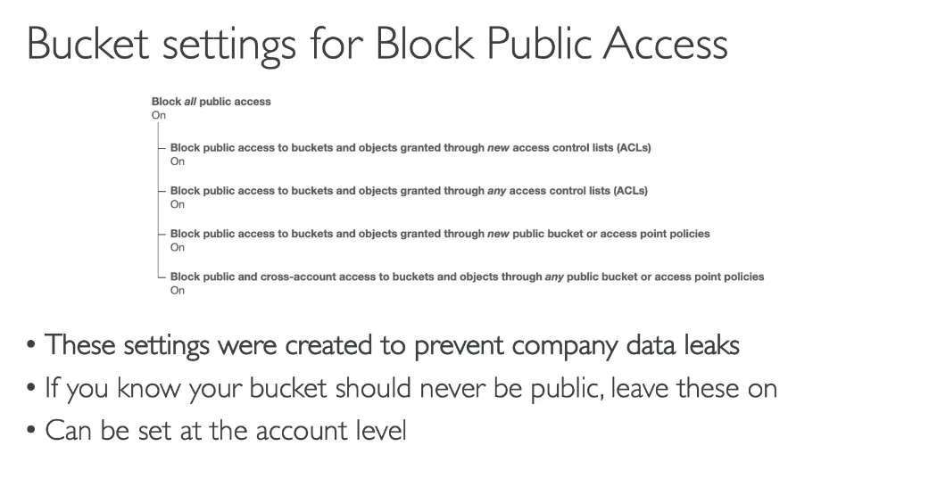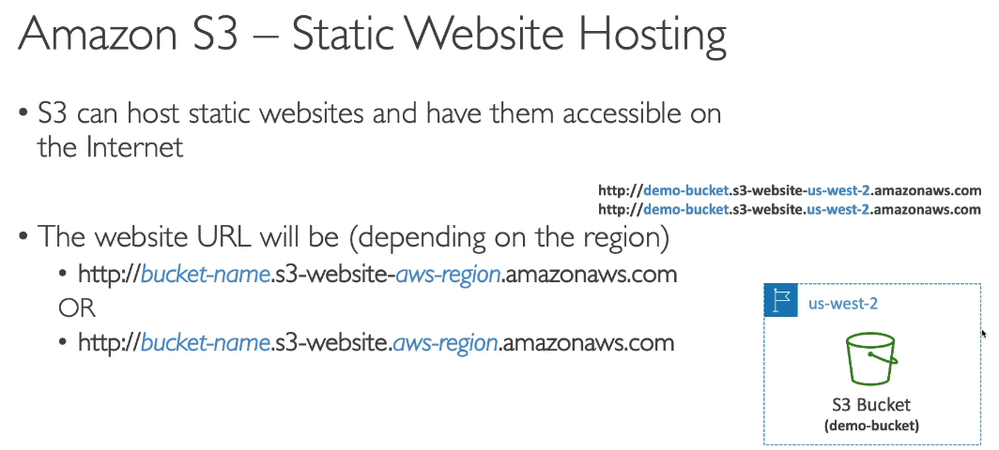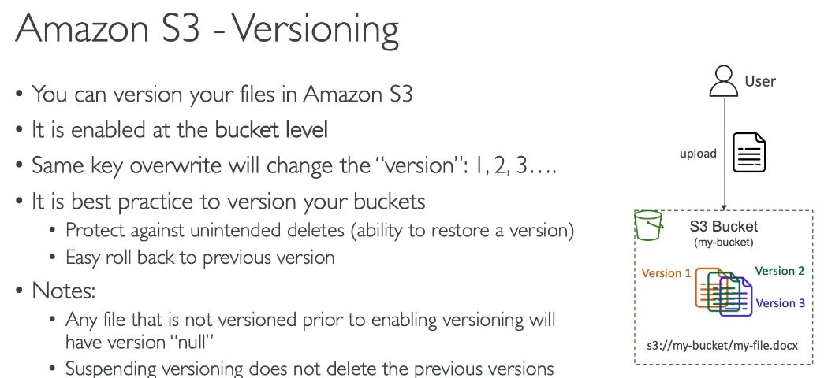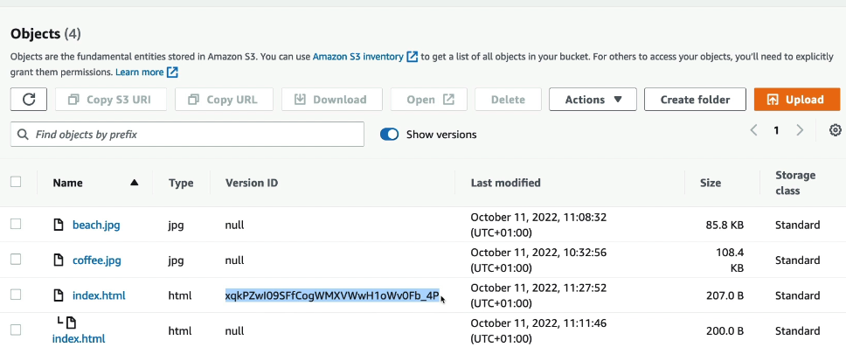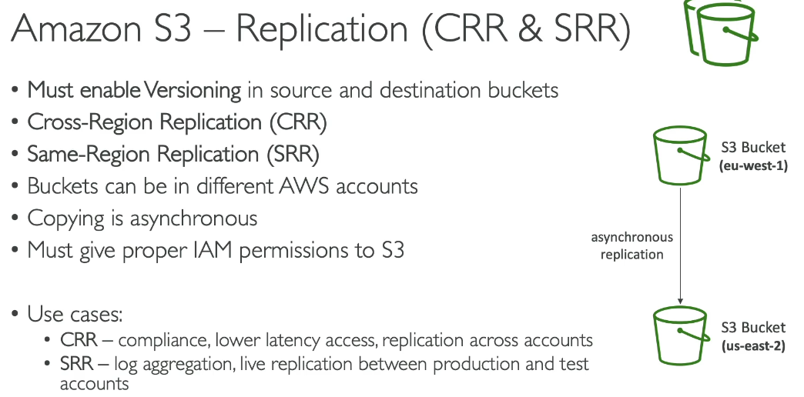**Amazon S3 offers two types of replication to automatically copy your objects between buckets:**

**Cross-Region Replication (CRR):**

* Copies objects between S3 buckets in different AWS Regions
* Use cases:
  + Meet compliance requirements for geographic redundancy
  + Minimize latency by keeping data closer to users in different locations
  + Disaster recovery across regions
  + Replicate data for operational reasons

**Same-Region Replication (SRR):**

* Copies objects between S3 buckets in the same AWS Region
* Use cases:
  + Aggregate logs from multiple buckets into one
  + Set up separate test and development environments
  + Meet data sovereignty laws (data must stay in specific region)
  + Protect against accidental deletion with cross-account replication

**How it works:**

1. Set up replication rules on your source bucket
2. Choose which objects to replicate (entire bucket or specific prefixes/tags)
3. S3 automatically and asynchronously copies objects to destination bucket(s)

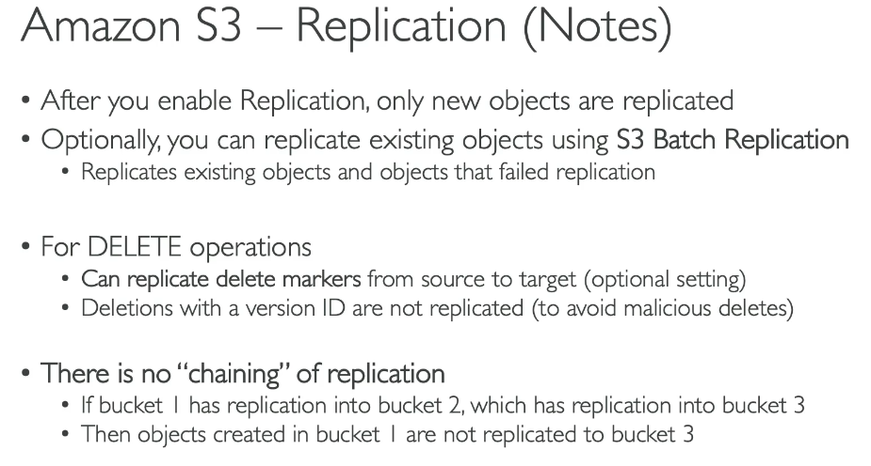vvvvvvvvv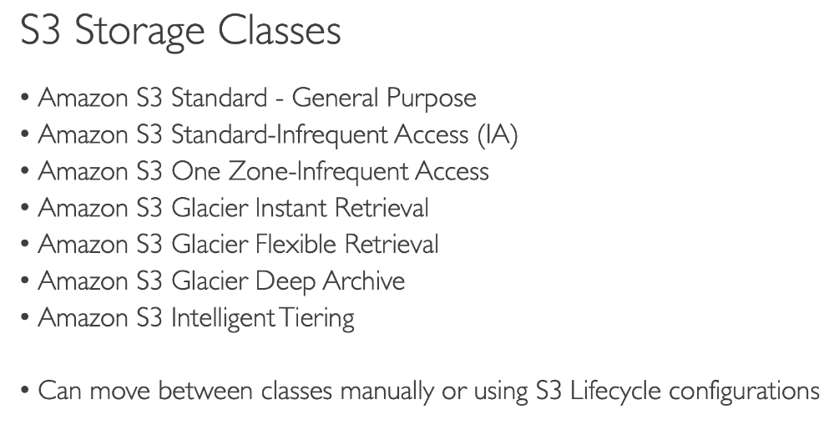

**Amazon S3 Storage Classes:**

**General Purpose:**

* **S3 Standard** - For frequently accessed data

**Unknown or Changing Access:**

* **S3 Intelligent-Tiering** - Automatic cost savings for data with unknown or changing access patterns

**High Performance:**

* **S3 Express One Zone** - For your most frequently accessed data

**Infrequent Access**:

* **S3 Standard-Infrequent Access (S3 Standard-IA)** - For less frequently accessed data
* **S3 One Zone-Infrequent Access (S3 One Zone-IA)** - For easily recreatable, less frequently accessed data

**Archive:**

* **S3 Glacier Instant Retrieval** - For archive data that needs immediate access
* **S3 Glacier Flexible Retrieval** - For rarely accessed long-term data that doesn't require immediate access
* **S3 Glacier Deep Archive** - For long-term archive and digital preservation with retrieval in hours at the lowest cost

**Data Residency:**

* **S3 Outposts** - For storing S3 data on-premises when you have data residency requirements.

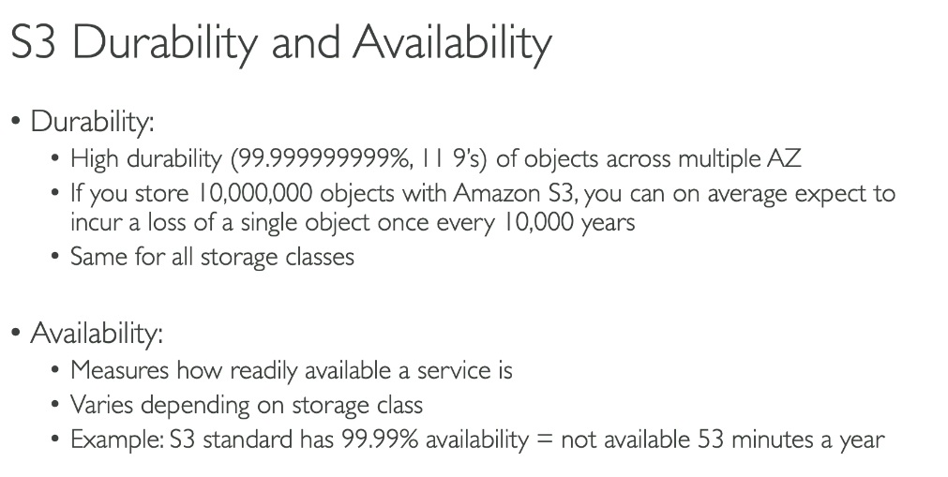

**Durability vs. Availability in Simple Terms:**

**Durability:**

* What it means: The probability that your data will NOT be lost or corrupted over time
* S3 Durability: 99.999999999% (11 9's) - meaning if you store 10,000 objects, you might lose one every 10 million years
* Example: Like storing a photo in a fireproof, waterproof safe with multiple backup copies in different locations. Even if one location is destroyed, your photo still exists elsewhere.

**Availability:**

* What it means: The probability that you can ACCESS your data when you need it
* S3 Availability: Ranges from 99.5% to 99.99% depending on storage class
* Example: Like a library that's open 99.9% of the time. Your book is safely stored (durable), but occasionally the library might be closed for maintenance (unavailable).

**Real-World Analogy: Think of a bank vault:**

* Durability = Your money won't disappear from the vault (data won't be lost)
* Availability = The bank is open when you need to access your money (you can retrieve your data)

Key Takeaway: S3 ensures your data is extremely safe from loss (durability) and accessible when needed (availability), though temporary access issues are more likely than actual data loss.

**Durability and Availability of S3 Storage Classes:**

**All storage classes have 99.999999999% (11 9's) durability, except:**

* S3 One Zone-IA: 99.999999999% durability within a single Availability Zone (but not resilient to AZ loss)

**Availability by Storage Class:**

**High Availability:**

* S3 Standard: 99.99%
* S3 Intelligent-Tiering: 99.9%
* S3 Express One Zone: 99.95%

**Infrequent Access:**

* S3 Standard-IA: 99.9%
* S3 One Zone-IA: 99.5%

**Archive Classes:**

* S3 Glacier Instant Retrieval: 99.9%
* S3 Glacier Flexible Retrieval: 99.99% (after restoration)
* S3 Glacier Deep Archive: 99.99% (after restoration)

Key Points:

* Storage classes with ≥3 Availability Zones (Standard, Standard-IA, Intelligent-Tiering, Glacier classes) are resilient to AZ loss
* One Zone classes (S3 One Zone-IA, S3 Express One Zone) store data in a single AZ, offering lower cost but less resilience
* All classes maintain extremely high durability through redundant storage

**Difference Between General Purpose Buckets and Directory Buckets:**

**General Purpose Buckets:**

* Default S3 bucket type used for the vast majority of S3 use cases
* Storage structure: Flat organization (no hierarchical structure)
* Storage classes: Supports all storage classes (Standard, Intelligent-Tiering, Standard-IA, One Zone-IA, Glacier classes)
* Availability: Stores data redundantly across multiple Availability Zones
* Performance: Standard performance with millisecond latency
* Naming: Must be globally unique across all AWS accounts
* Access control: Supports ACLs, bucket policies, and granular access controls
* Public access: Can be configured for public access (though blocked by default)

**Directory Buckets:**

* Purpose-built for performance-critical, low-latency applications
* Storage structure: Hierarchical organization using directories (prefixes)
* Storage class: Only supports S3 Express One Zone
* Availability: Single Availability Zone (you choose which one)
* Performance: Single-digit millisecond latency - up to 10x faster than S3 Standard
* Naming: Must be unique within the chosen Availability Zone; name automatically includes AZ ID suffix (e.g., --usw2-az1--x-s3)
* Access control: ACLs disabled; Block Public Access always enabled and cannot be modified
* Encryption: Only SSE-S3 supported

Key Takeaway: Choose general purpose buckets for most use cases with flexible storage options. Choose directory buckets when you need the fastest possible performance and can store data in a single Availability Zone.

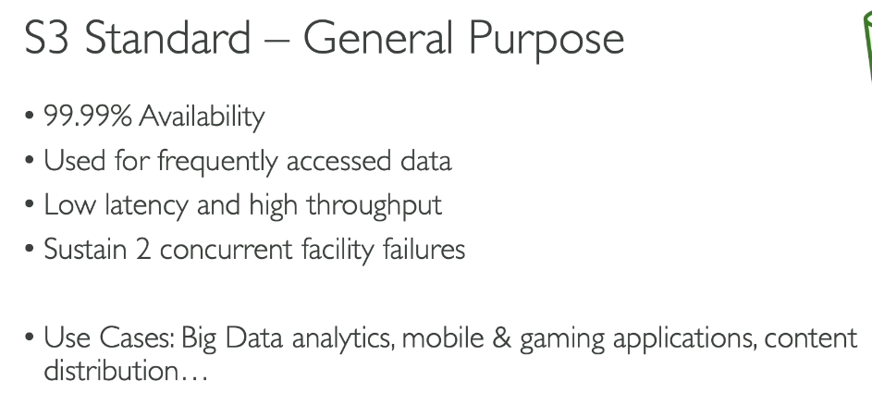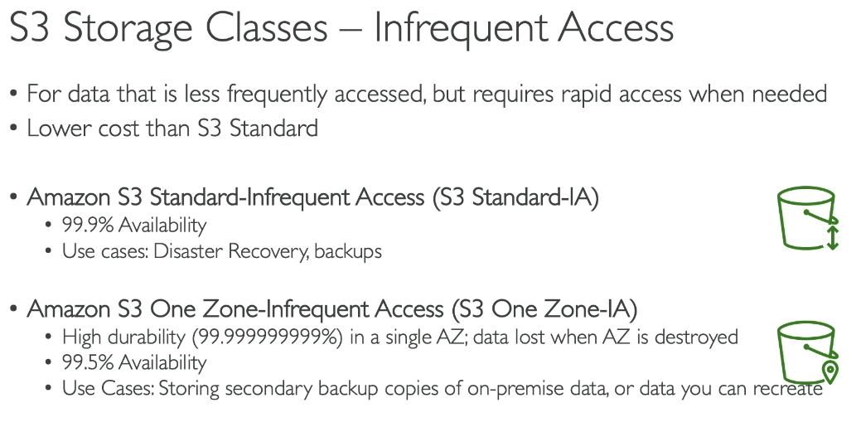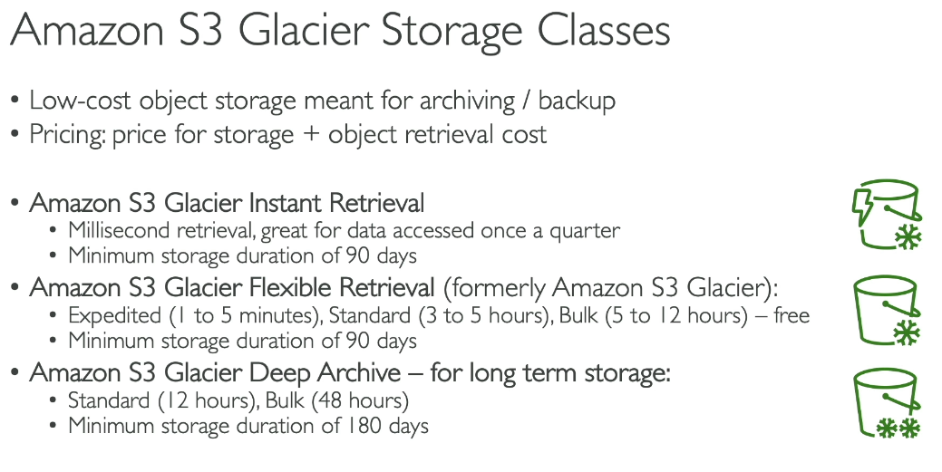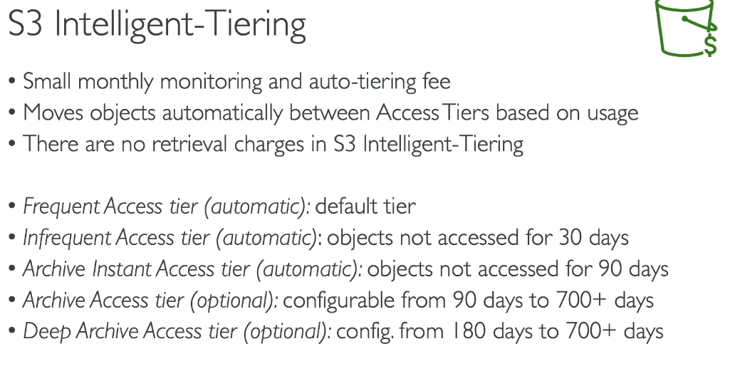 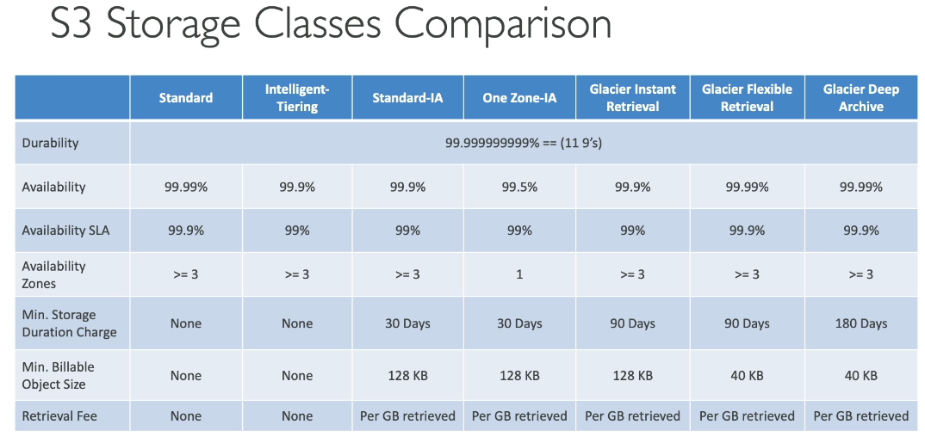**High Performance Storage Class:**

Amazon S3 has one dedicated high-performance storage class:

**S3 Express One Zone:**

* Purpose-built for consistent single-digit millisecond data access
* Delivers up to 10x better performance than S3 Standard
* Handles hundreds of thousands of requests per second
* Supports up to 2 million requests per second per directory bucket
* Stores data in a single Availability Zone of your choice
* Ideal for latency-sensitive applications and most frequently accessed data
* Request costs up to 50% lower than S3 Standard

Key Benefits:

* Co-locate storage and compute resources in the same Availability Zone to further reduce latency
* Uses a different bucket type called "directory bucket" for enhanced performance
* Best for workloads requiring the fastest possible data access speeds This is the only storage class specifically designed and optimized for high-performance use cases in S3.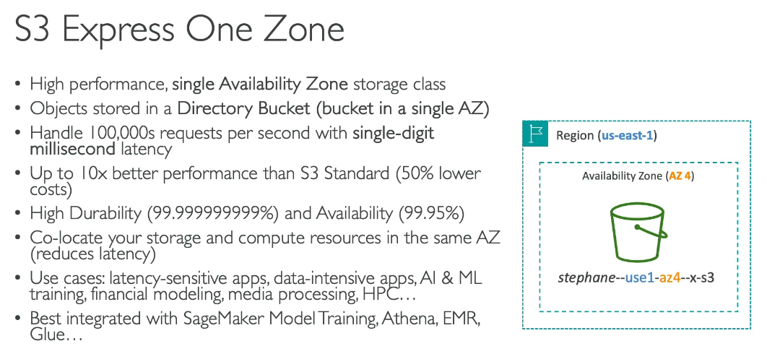

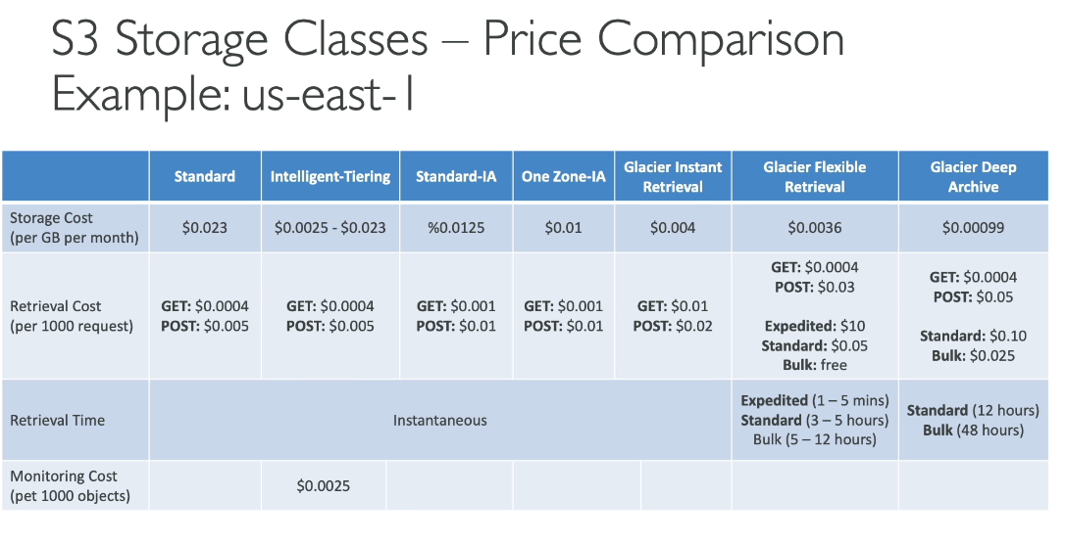

**S3 Advanced**

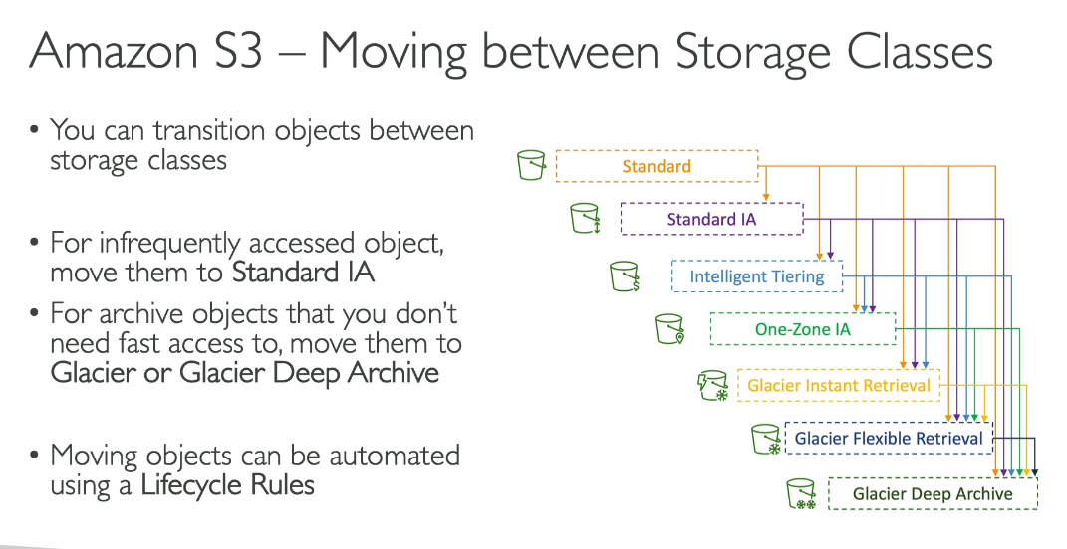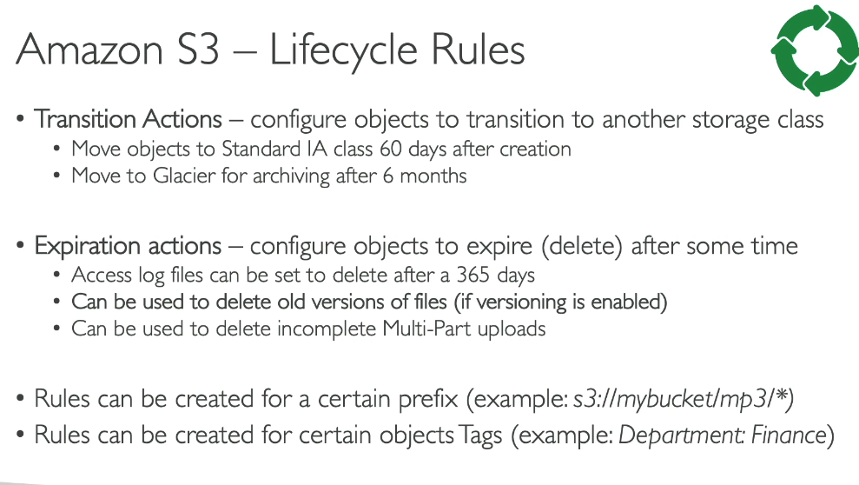  
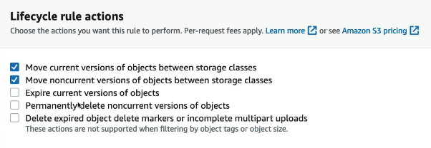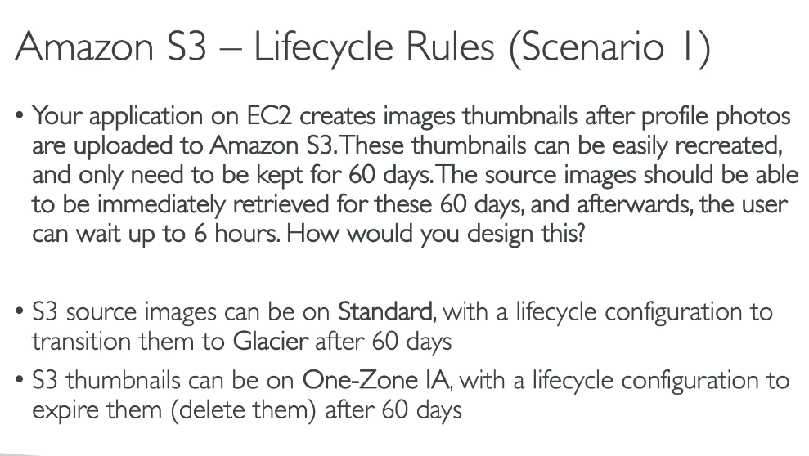

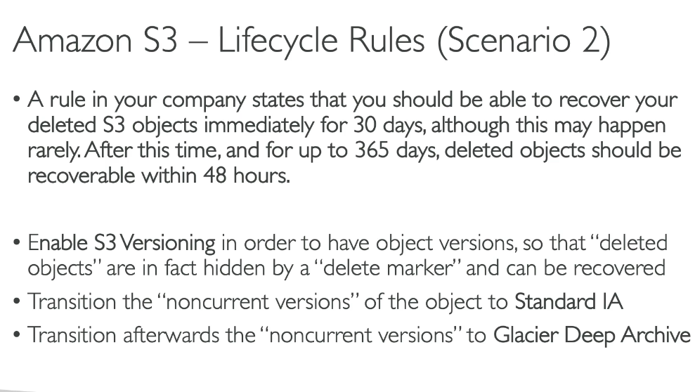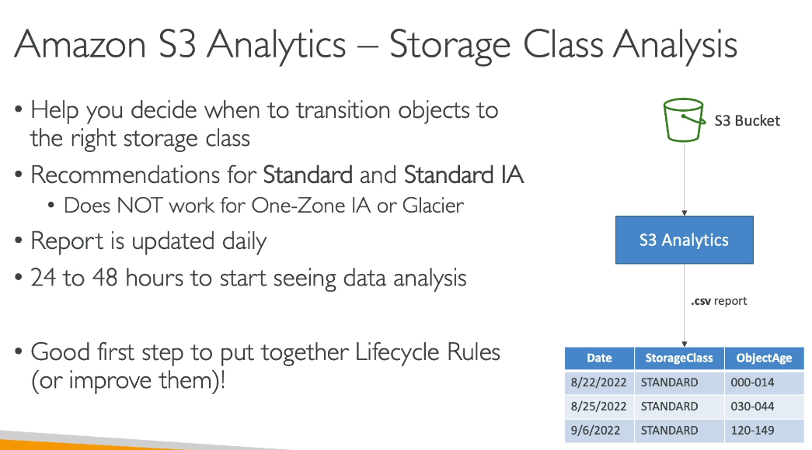

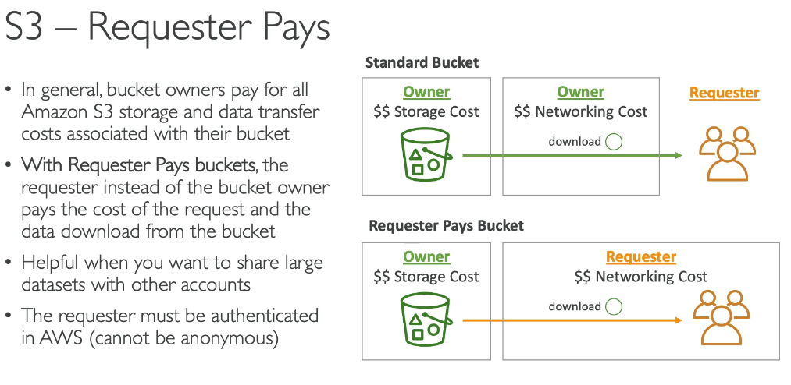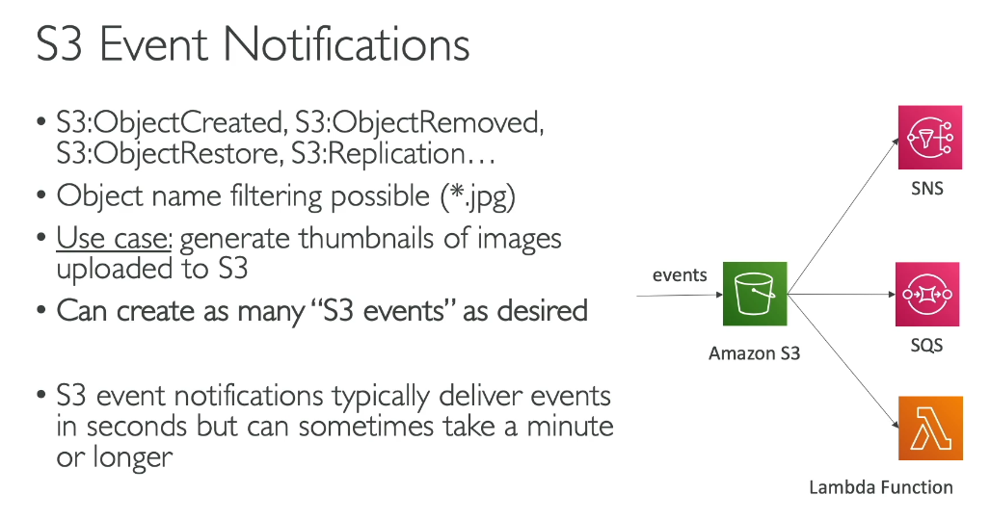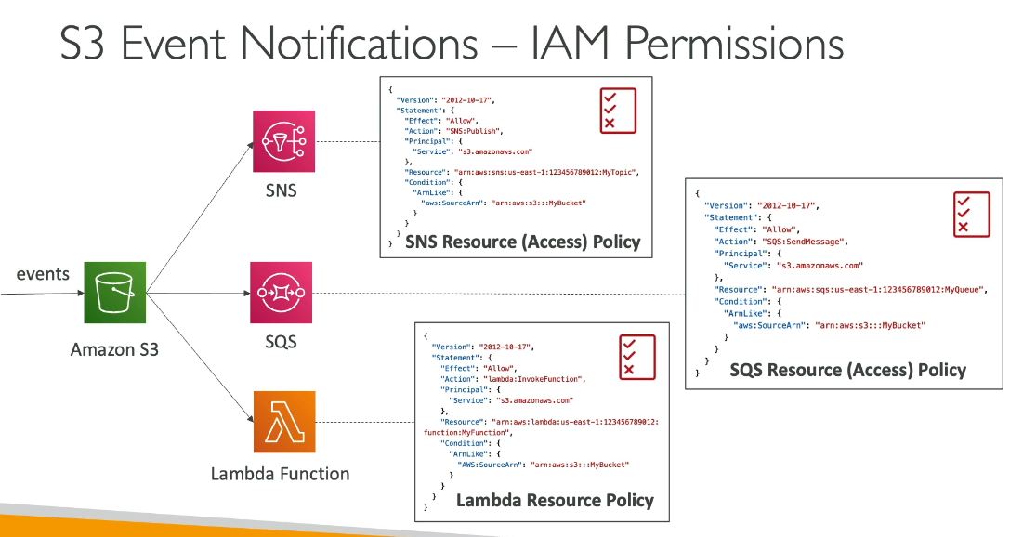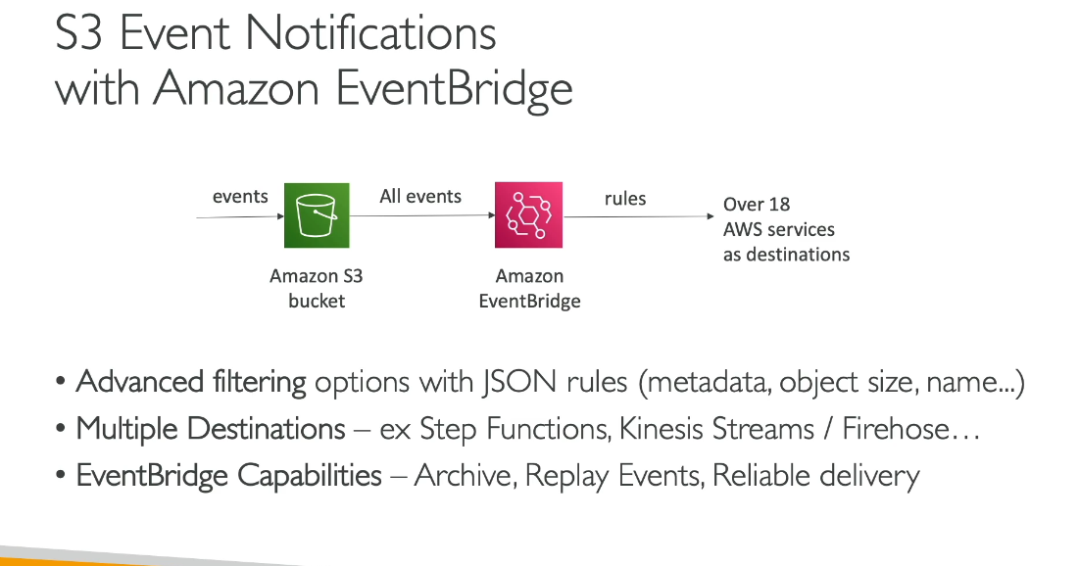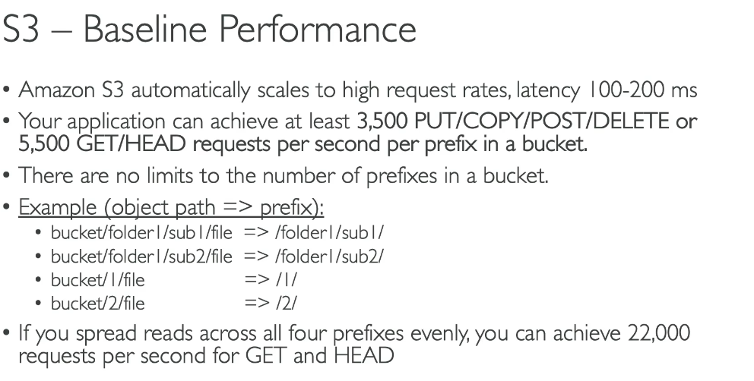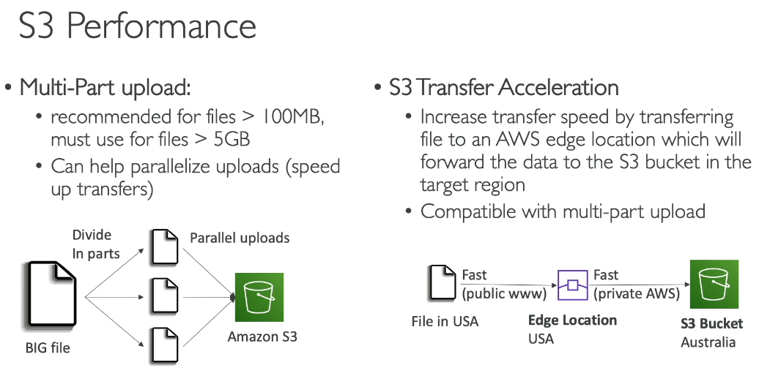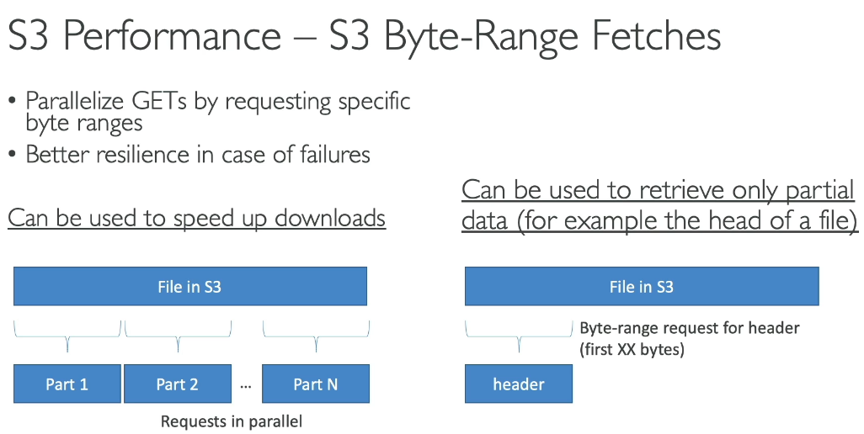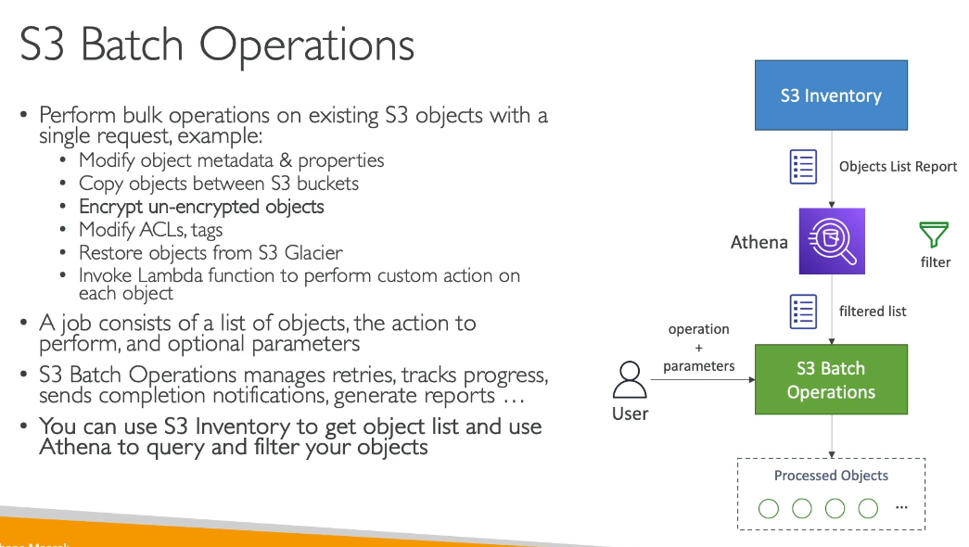**S3 Batch Operations must be explicitly enabled and configured by the user - it does not happen automatically.**

**How It Works:**

User-Initiated Process:

1. You create a Batch Operations job through the S3 console, AWS CLI, or SDK
2. You specify:
   1. List of target objects (via S3 Inventory report or custom manifest)
   2. Operation to perform (copy, tag, restore, etc.)
   3. IAM role with necessary permissions
3. You review and confirm the job before it runs
4. S3 Batch Operations executes the job on your behalf

Not Automatic:

* AWS does NOT automatically detect bulk operations and convert them to Batch Operations
* If you perform bulk operations without using Batch Operations (e.g., scripting individual API calls), AWS processes them as individual requests
* You must explicitly choose to use S3 Batch Operations

Key Benefits of Using Batch Operations:

* Manages retries automatically
* Tracks progress and completion
* Generates detailed completion reports
* Provides notifications
* More cost-effective for large-scale operations

Example:

* Without Batch Operations: You write a script to copy 1 million objects - each is an individual API call
* With Batch Operations: You create one job to copy 1 million objects - S3 manages the entire process

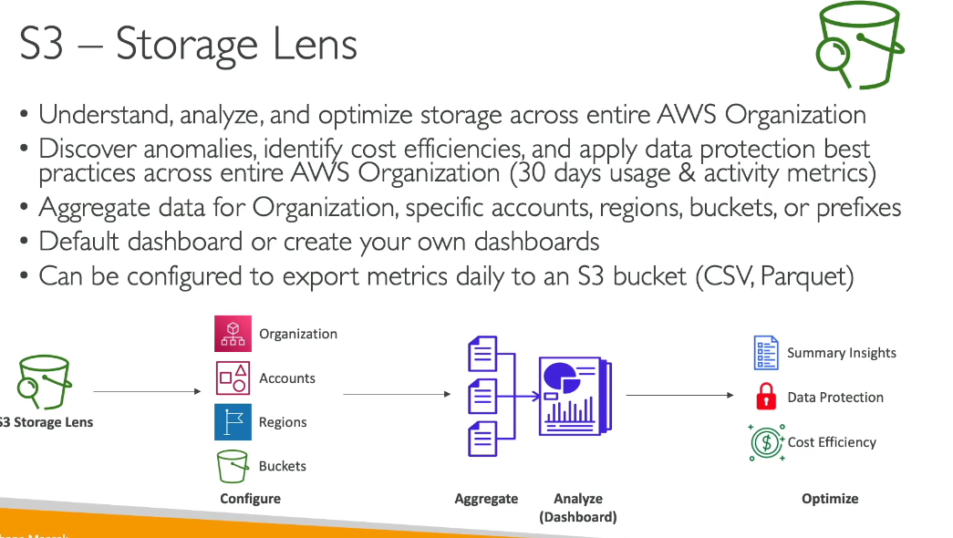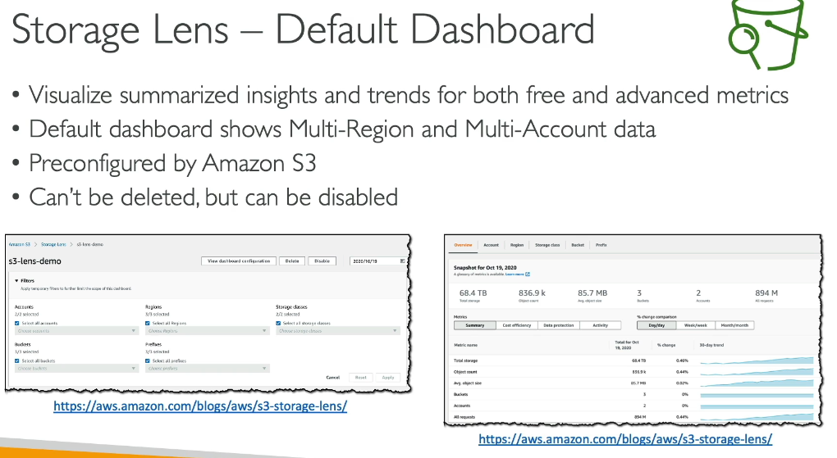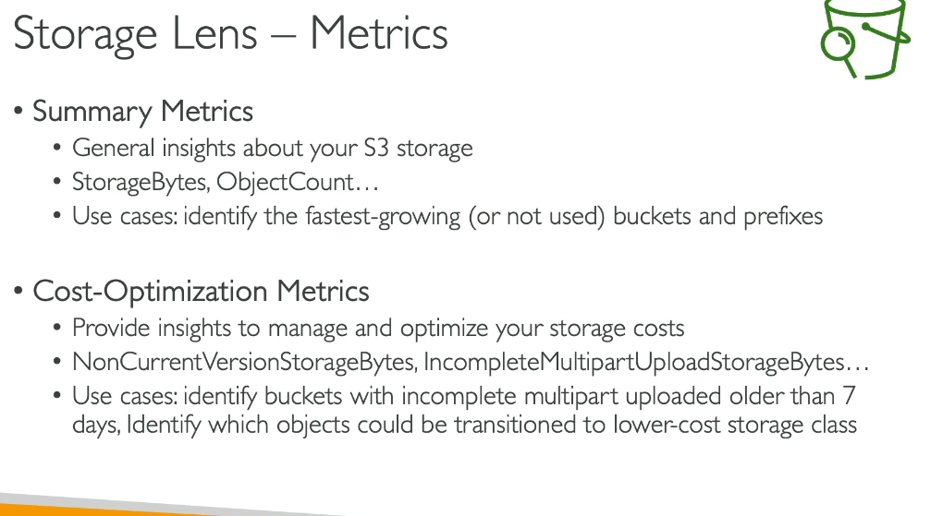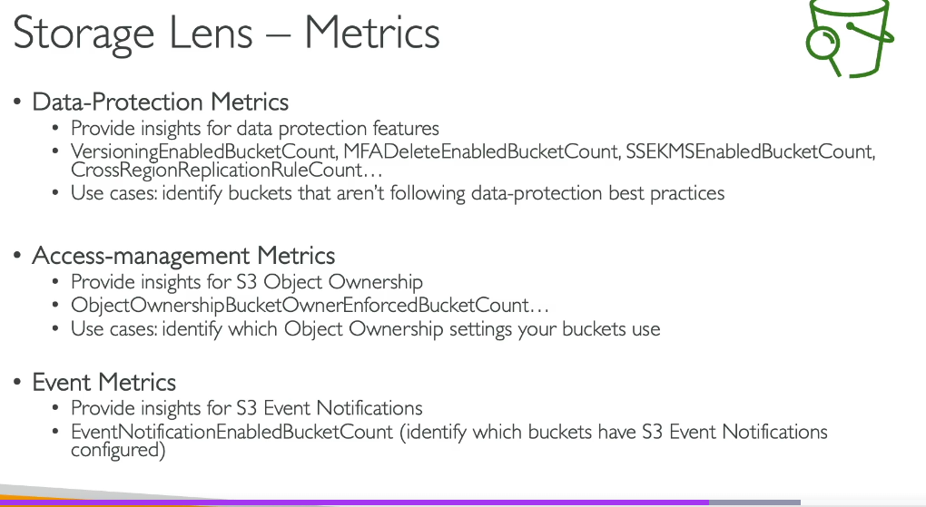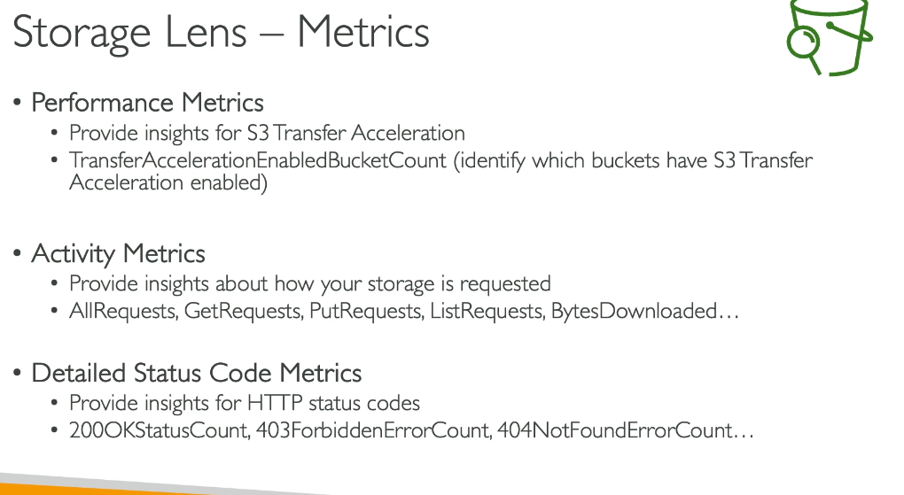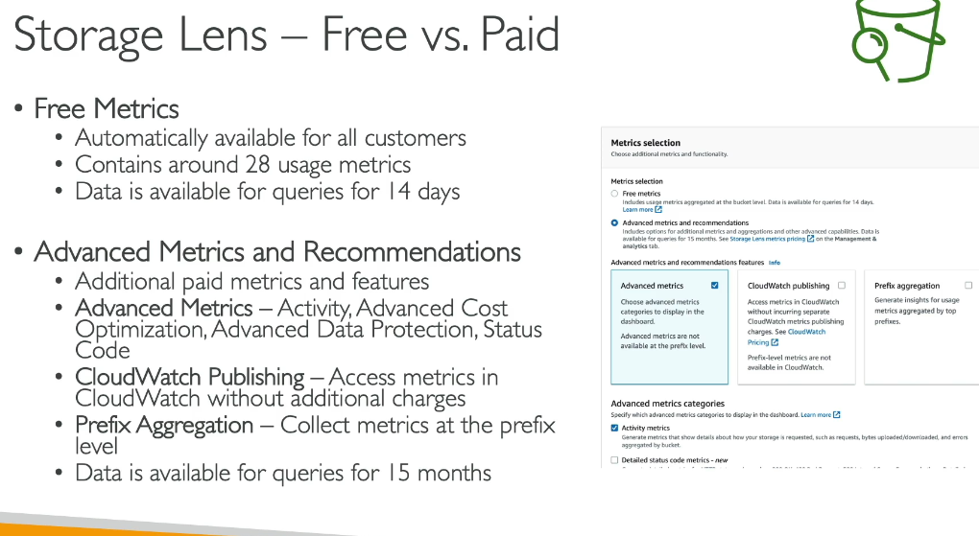

**S3 SECURITY**

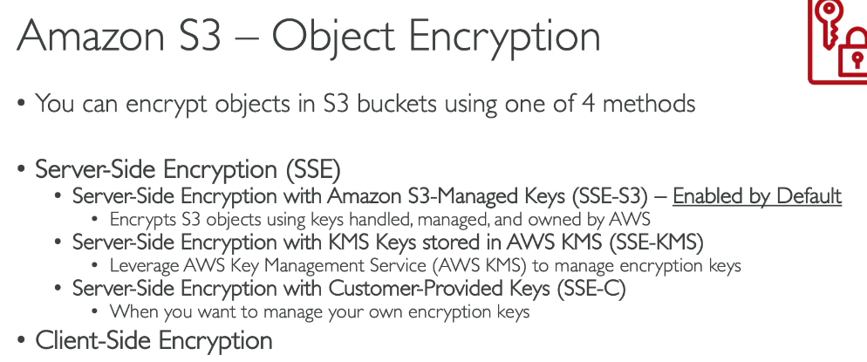  
**SSE-C Can be performed via AWS CLI**  
  
**S3 Server-Side vs Client-Side Encryption:**

**Server-Side Encryption (SSE):**

* What: Data is encrypted by Amazon S3 after it receives your objects
* Where: Encryption happens at AWS data centers when writing to disks
* Key Management: AWS manages the encryption/decryption process
* Access: Transparent to users - S3 automatically decrypts when you retrieve objects

**Client-Side Encryption:**

* What: Data is encrypted before uploading to S3
* Where: Encryption happens on your side (application/client)
* Key Management: You control and manage encryption keys (not AWS)
* Access: You must decrypt objects after downloading them

**Why Needed:**

**Security Requirements:**

* Protect sensitive data at rest
* Meet compliance regulations (HIPAA, PCI-DSS, GDPR)
* Prevent unauthorized access to data

**Different Use Cases:**

Server-Side Encryption (SSE-S3):

* Use Case: Healthcare provider storing patient records
* Why: Simple implementation, AWS manages keys, meets compliance requirements
* Benefit: Automatic encryption with no code changes needed

Client-Side Encryption:

* Use Case: Financial institution storing customer financial data
* Why: Requires complete control over encryption keys for regulatory compliance
* Benefit: Data encrypted before leaving your premises, ensuring data sovereignty
* Example: Bank encrypts transaction data with their own keys before uploading to S3

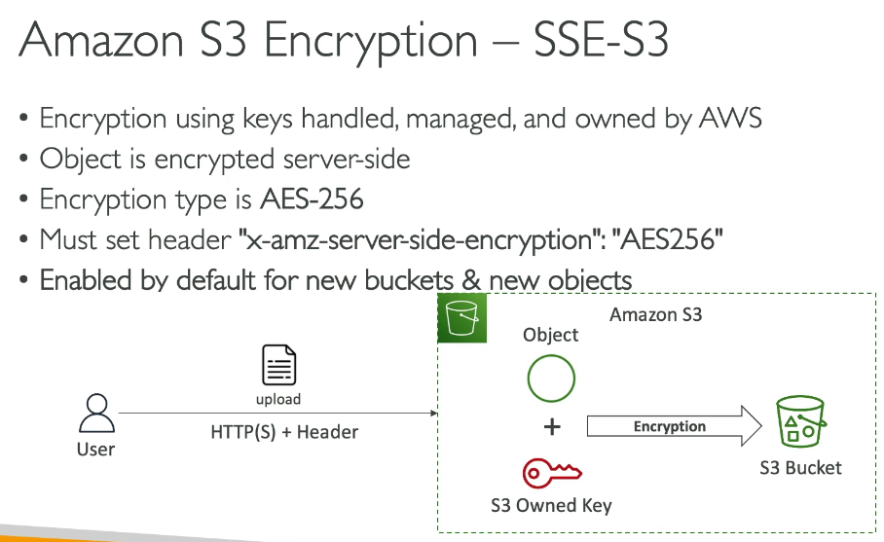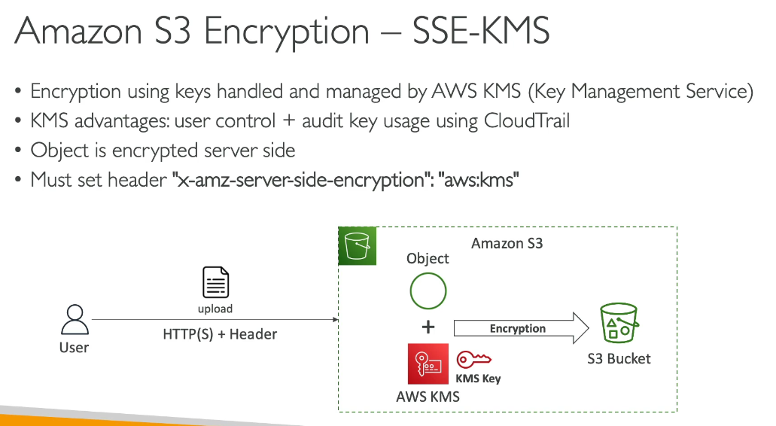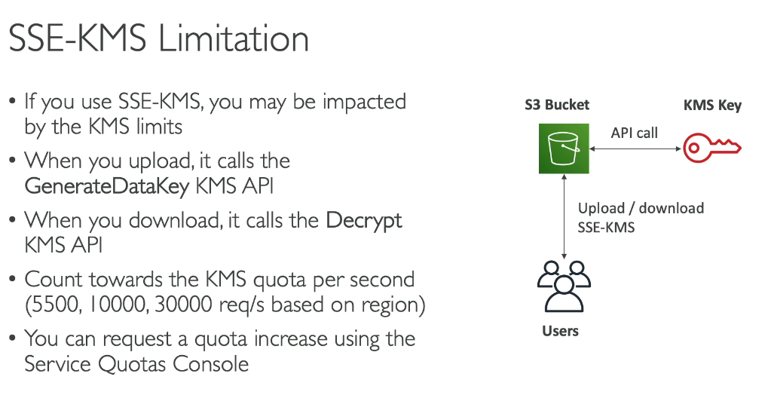

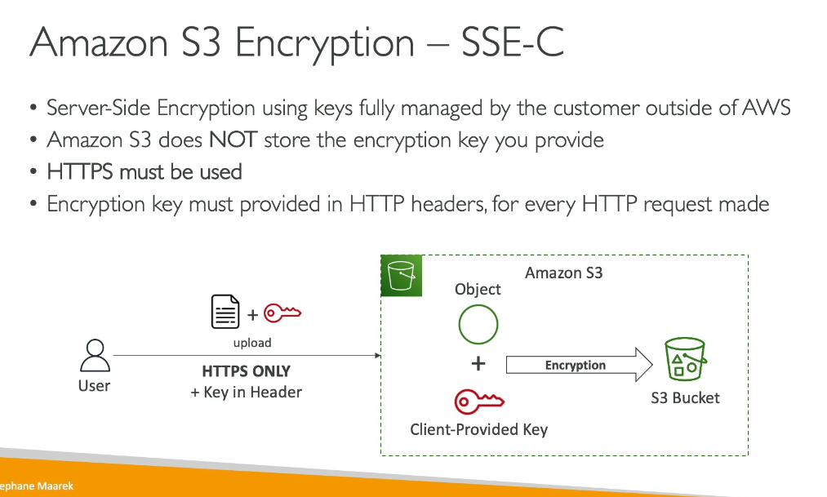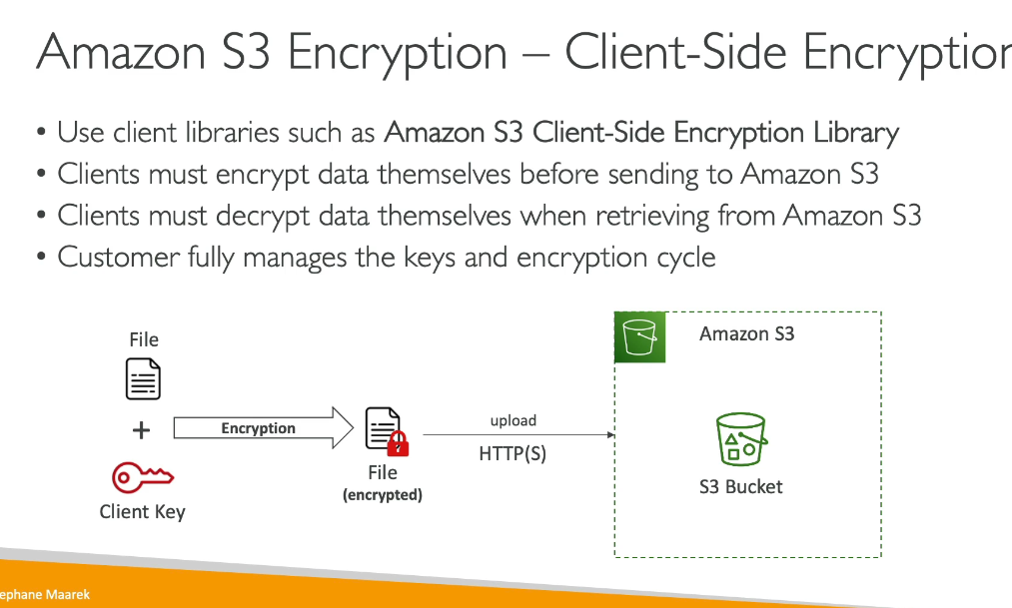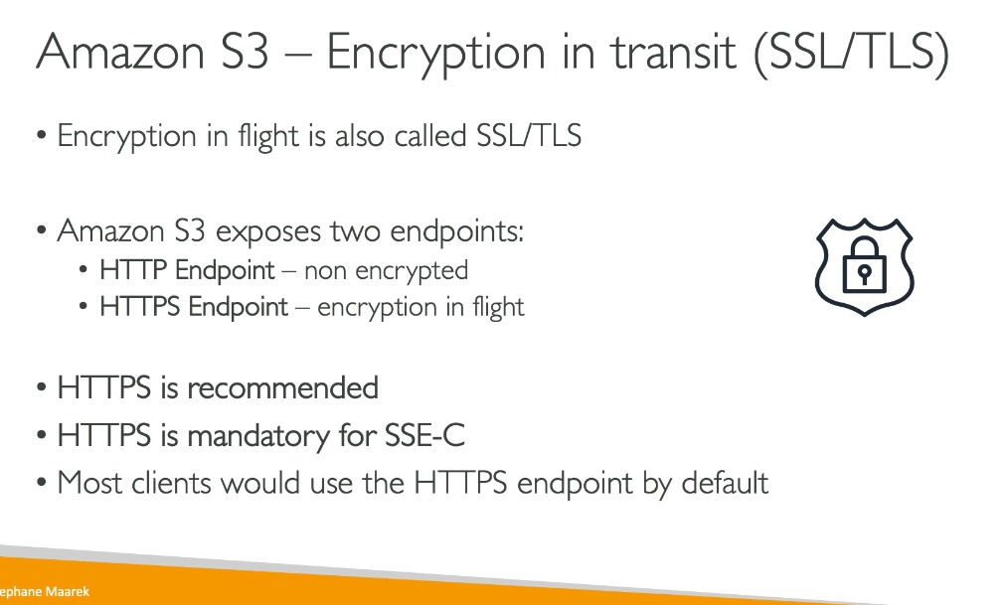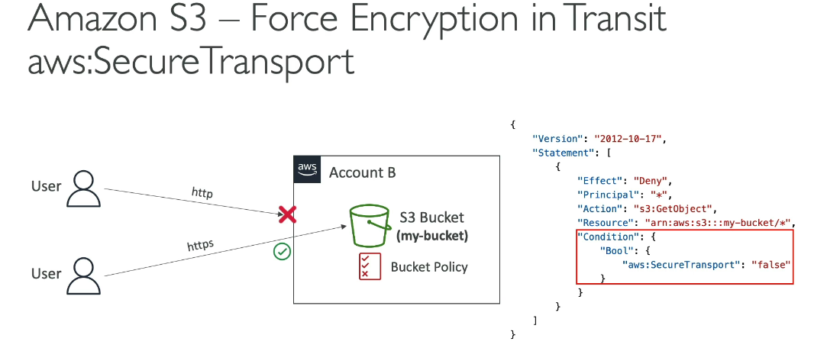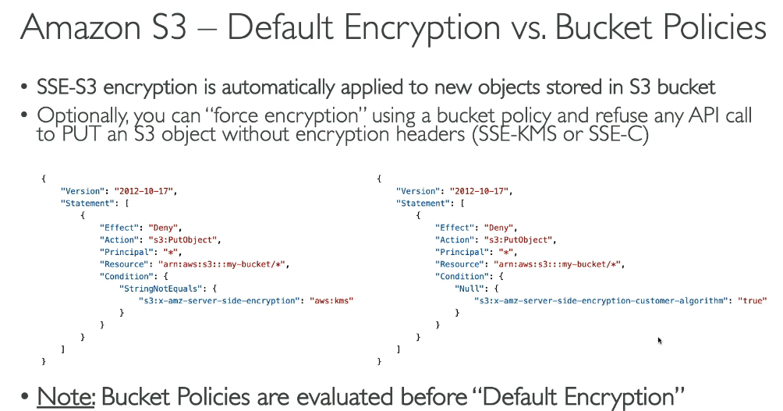

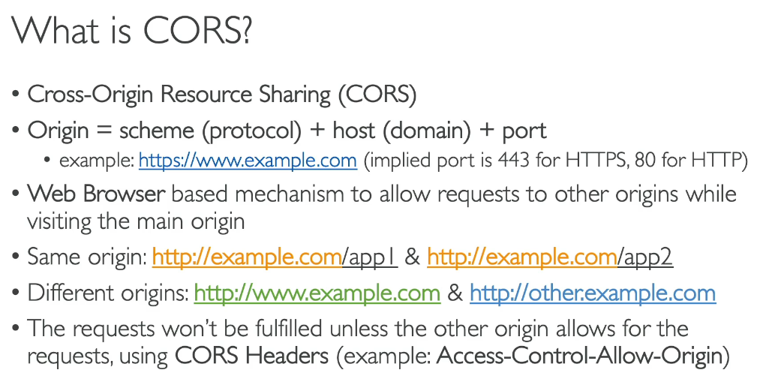

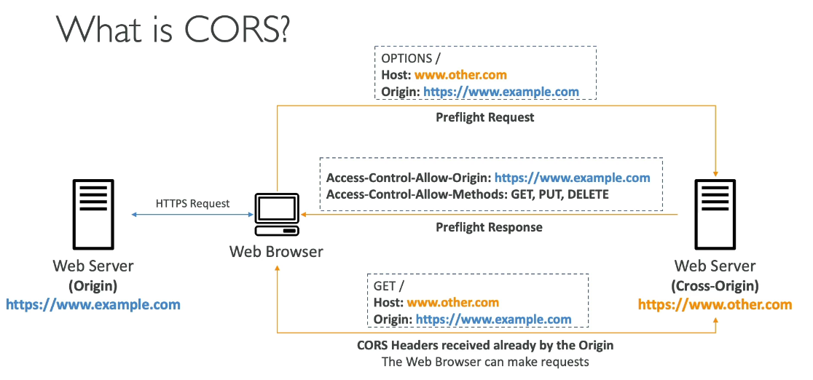

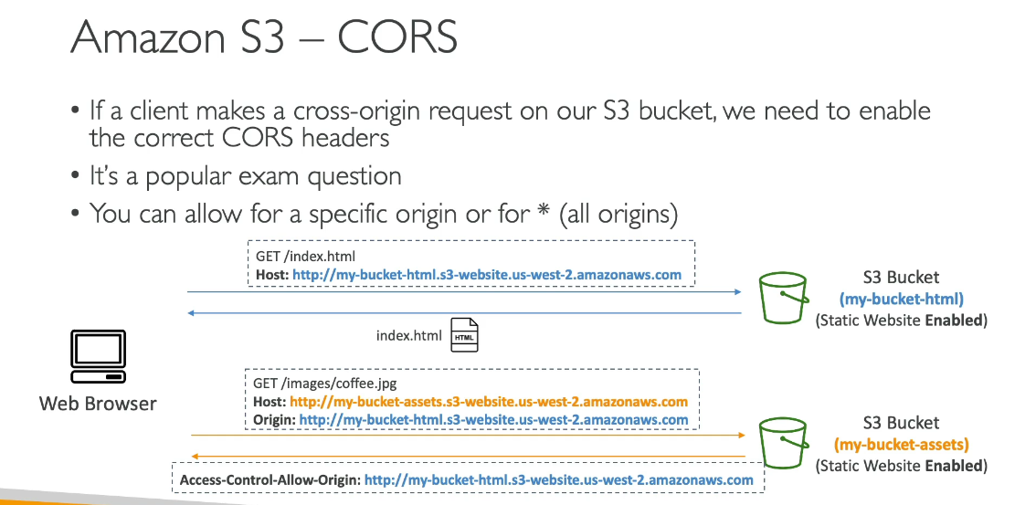

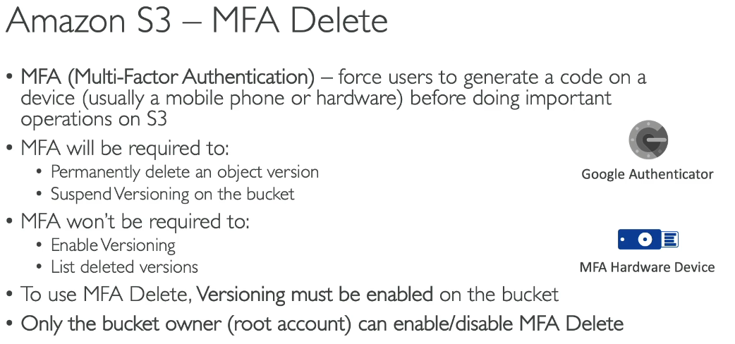

**MFA for an bucket can be enabled only via AWS CLI, SDK and S3 REST API**

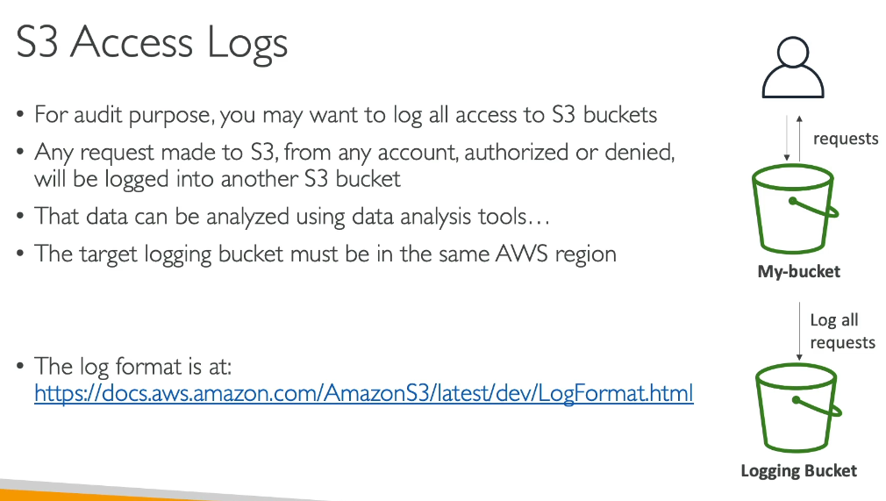

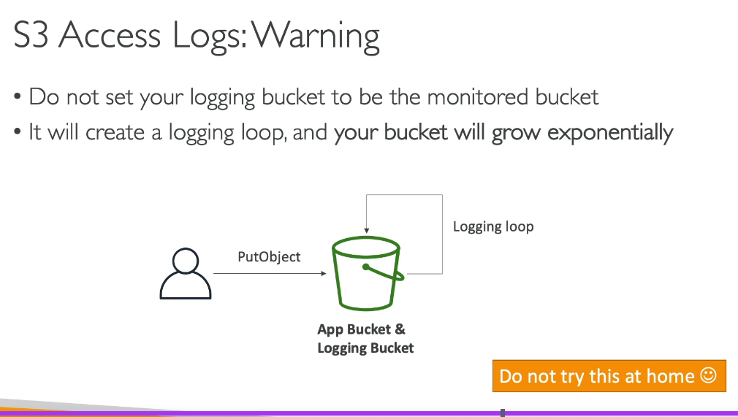

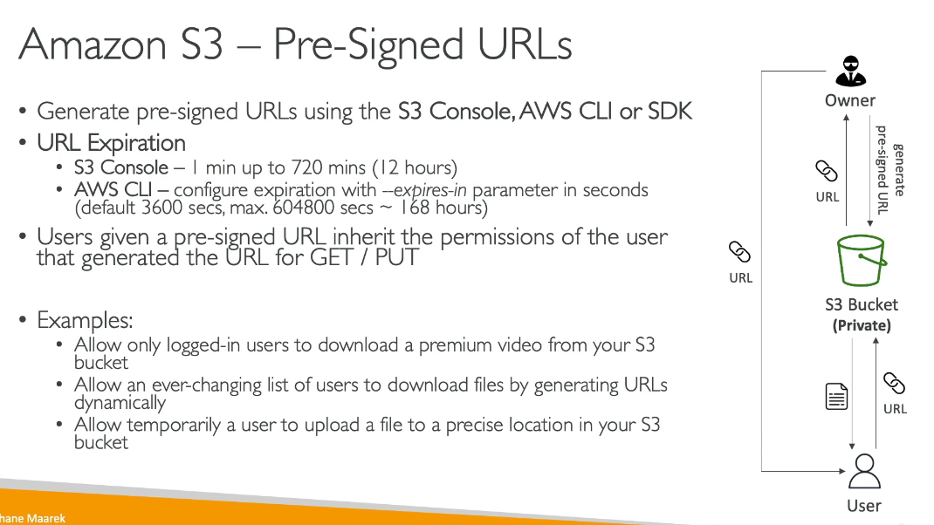

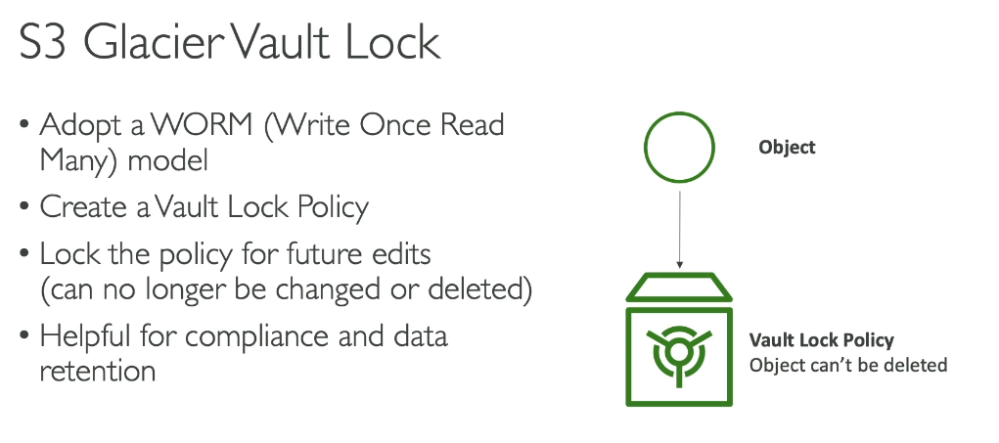

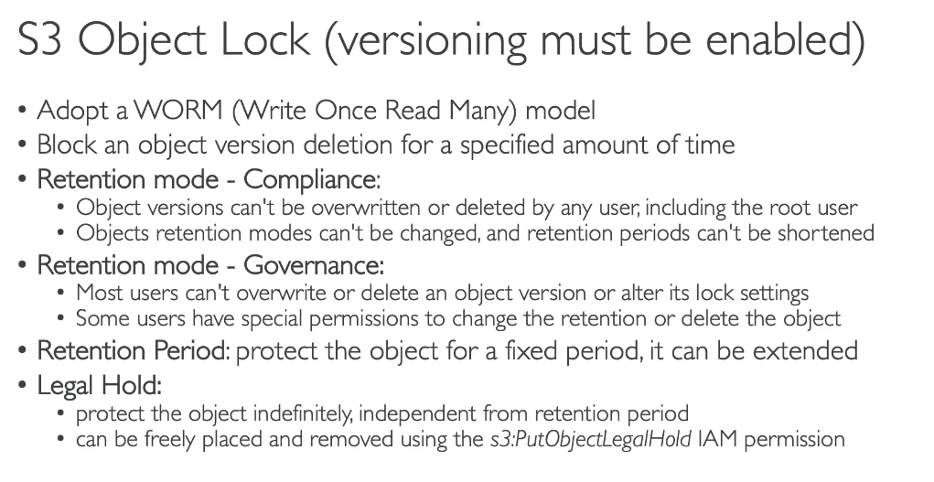

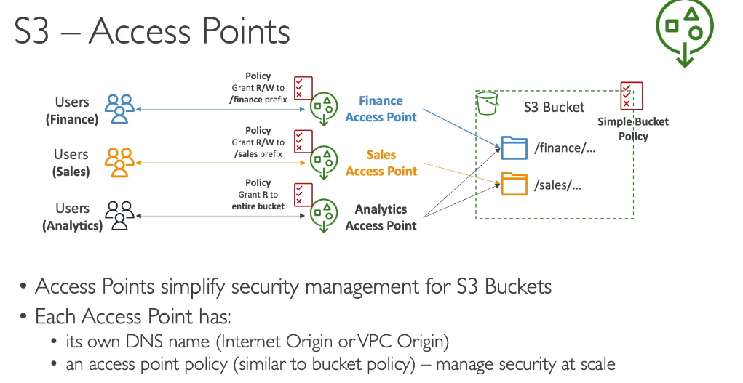

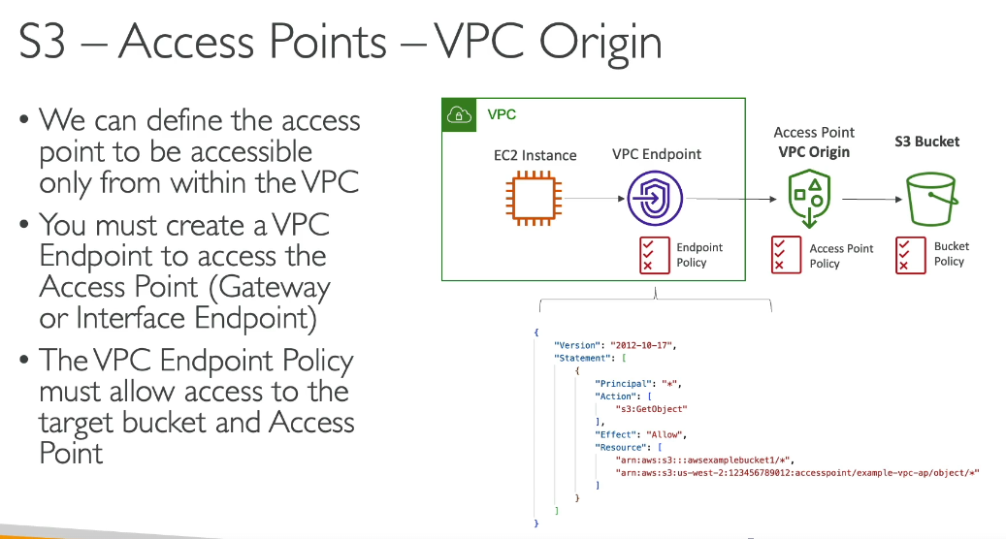

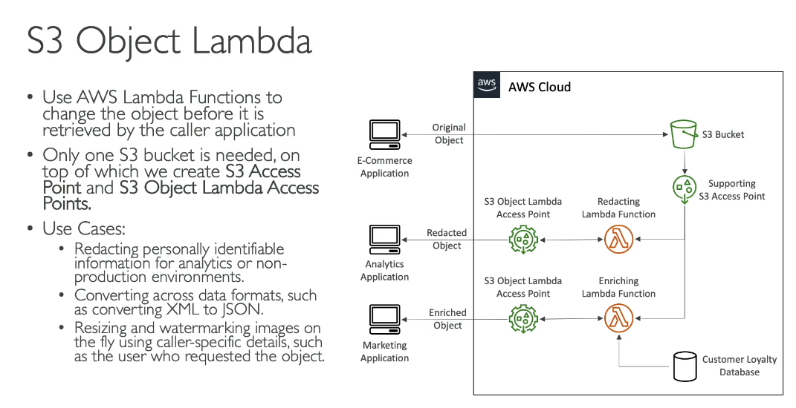

**Amazon S3 Left-SidebarFeatures Explained:**

**Buckets:**

**1. General Purpose Buckets**

* What: Original S3 bucket type for storing any objects across all storage classes (except S3 Express One Zone)
* Use Case: Most common use cases - website hosting, backups, data lakes
* Example: E-commerce company storing product images, customer data, and transaction logs

**2. Directory Buckets**

* What: High-performance buckets for S3 Express One Zone storage class
* Use Case: Low-latency applications requiring fast data processing within single Availability Zone
* Example: Real-time analytics processing sensor data from IoT devices, supporting up to 2 million transactions/second

**3. Table Buckets**

* What: Purpose-built for storing tabular data in Apache Iceberg format
* Use Case: Analytics and ML workloads with structured data
* Example: Storing daily purchase transactions, streaming sensor data with automatic query optimization

**4. Vector Buckets**

* What: Specialized for storing and querying vector data
* Use Case: AI/ML applications requiring semantic search
* Example: Storing embeddings for recommendation systems or similarity searches

**Access Management:**

**5. Access Points**

* What: Named network endpoints with dedicated access policies for shared datasets
* Use Case: Multiple teams accessing same bucket with different permissions
* Example: Finance team gets read-only access while Analytics team gets read-write access to same data lake

**6. Access Points for FSx**

* What: Connects Amazon FSx file systems to S3
* Use Case: File-based workloads needing S3 integration
* Example: Windows applications accessing S3 data through familiar file system interface

**7. Access Grants**

* What: Grant temporary, fine-grained access to S3 data using corporate identities
* Use Case: External partners needing temporary access
* Example: Contractor gets 30-day access to specific project folders without creating AWS IAM users

**8. IAM Access Analyzer**

* What: Identifies resources shared with external entities
* Use Case: Security auditing and compliance
* Example: Detecting accidentally public S3 buckets or overly permissive policies

**Storage Management:**

**9. Storage Lens**

* What: Organization-wide visibility into storage usage and activity metrics
* Use Case: Cost optimization and usage analysis across accounts
* Example: Identifying underutilized storage, tracking growth trends, finding cost-saving opportunities

**10. Batch Operations**

* What: Perform large-scale operations on billions of objects
* Use Case: Bulk modifications without writing scripts
* Example: Copying 10 million objects between buckets, changing storage class for millions of files, or bulk tagging

**11. Account and Organization Settings**

* What: Configure default settings across AWS accounts
* Use Case: Enforce security standards organization-wide
* Example: Block public access by default for all new buckets across all accounts

**12. AWS Marketplace for S3**

* What: Discover and deploy third-party data and applications
* Use Case: Access commercial datasets or data processing tools
* Example: Subscribe to financial market data, weather datasets, or data transformation tools directly integrated with S3 Each feature addresses specific needs - from basic storage (general purpose buckets) to advanced security (Access Grants) and enterprise management (Storage Lens).

**Quiz-1**

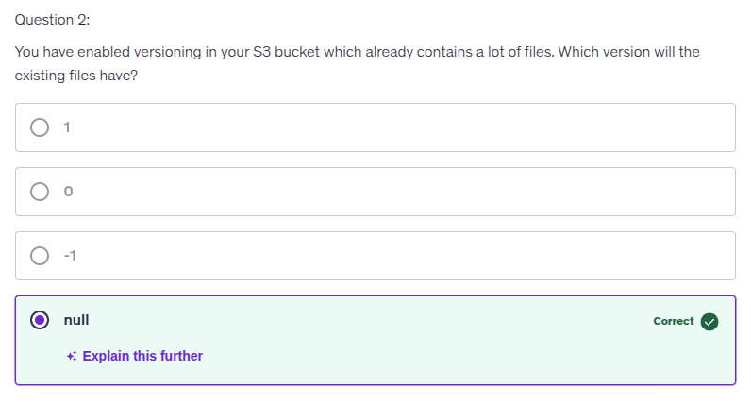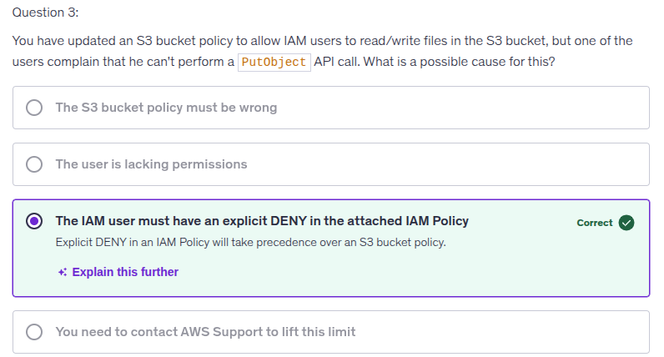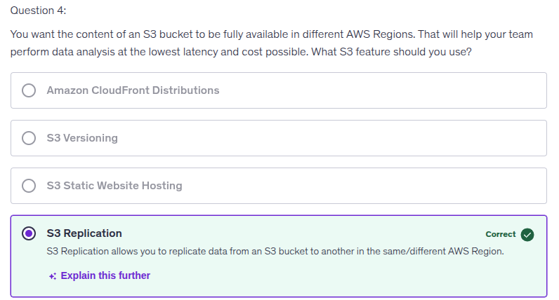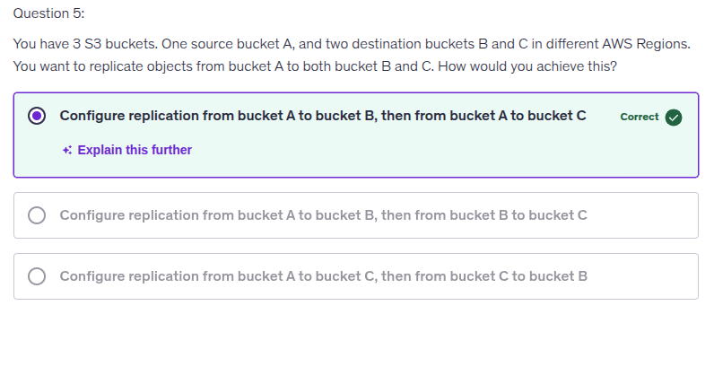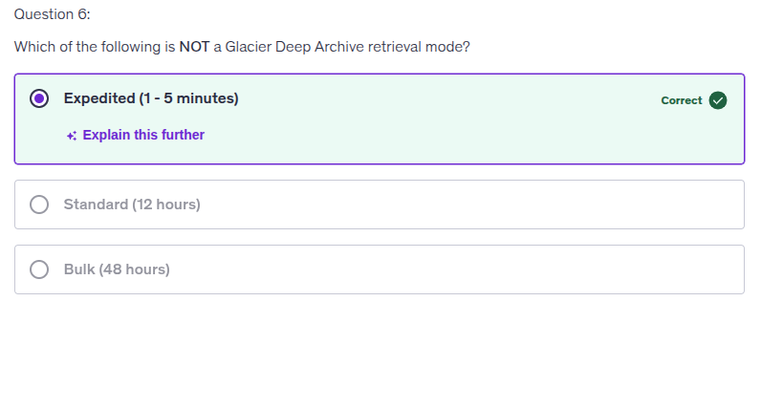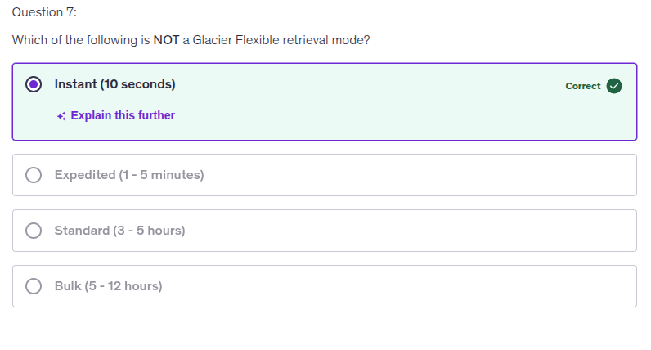

**Quiz-2:**

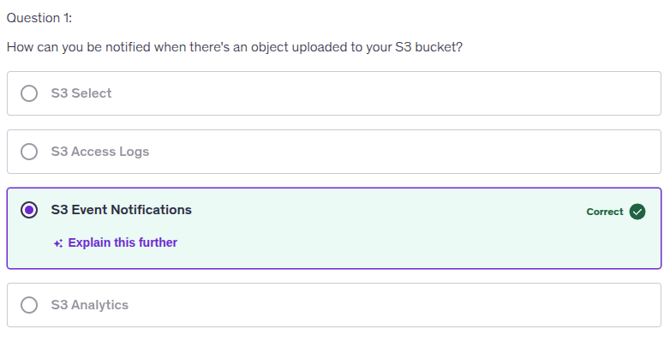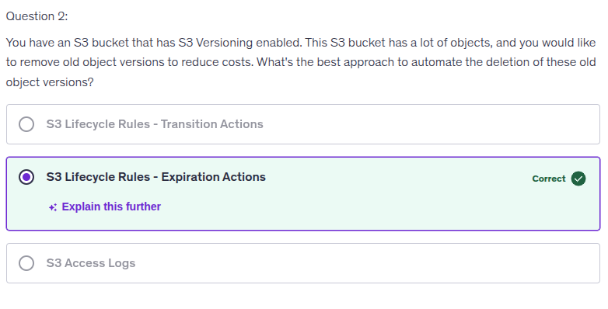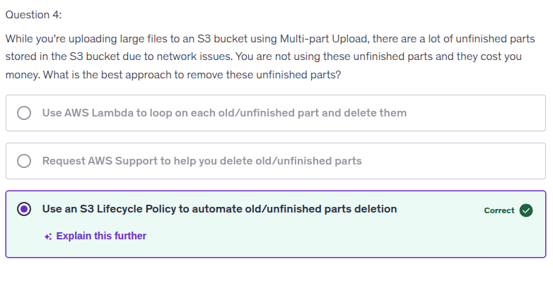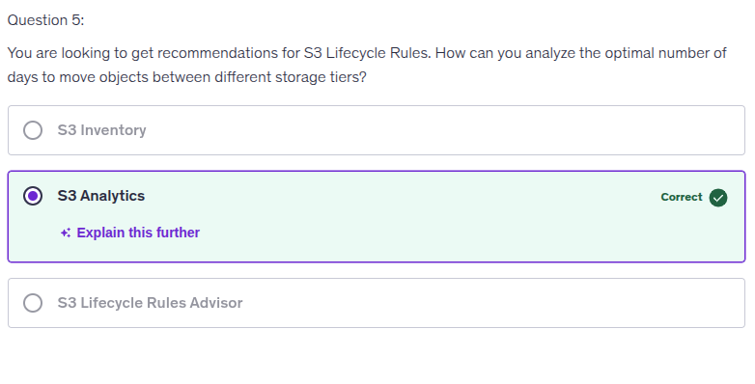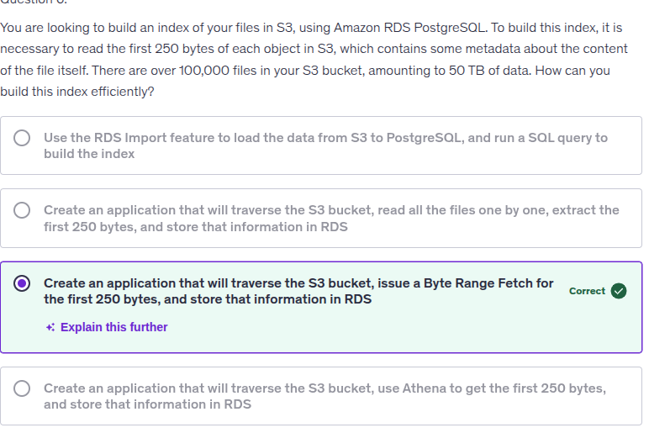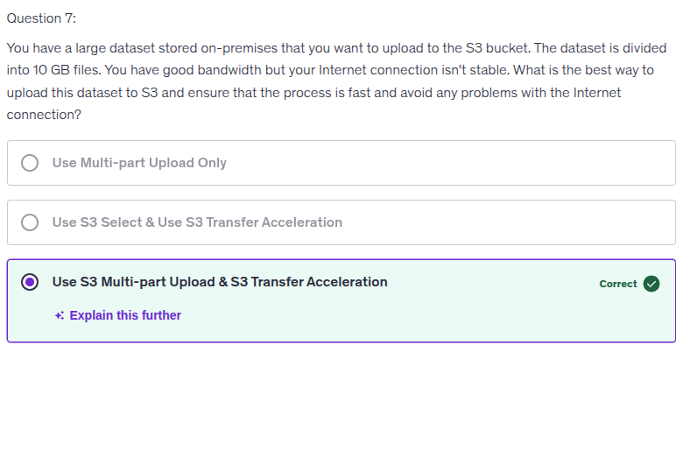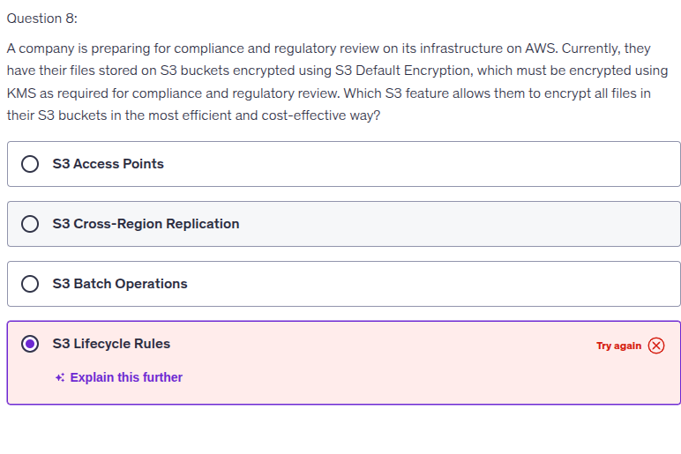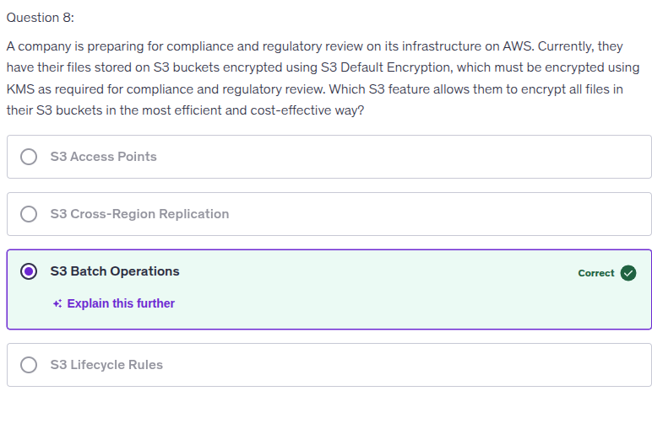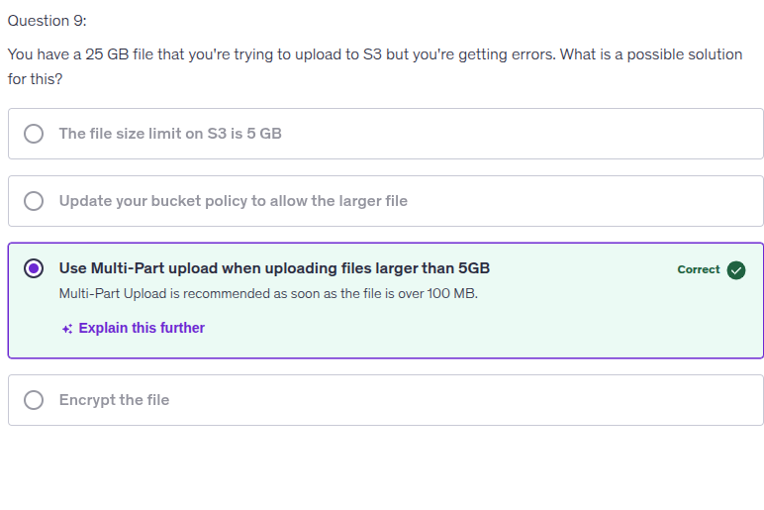

**Security Quiz:**

